Lab 5 Setting The Bullet and the bullet Trajectory
Add a new image control and set the picture property to shell.bmp – you will find this image on Blackboard.

To fire each player will use a key and therefore this ‘event will be under the KeyPressed Event:

public void OnKeyDown(Object sender, KeyEventEventArgs e)
{

if (e.KeyCode.ToString() == 'Q')
//PLAYER 1 FIRING USING ‘Q’ KEY

if (e.KeyCode.ToString() == '5')

// PLAYER 2 FIRING USING ‘5’ KEY

if (e.KeyCode.ToString() == 'A')
{….
Code as in the previous labs

We need to set the direction that the bullet will travel
We will need to set the initial position of the shell based on the tanks position i.e. the start position will be at the gun position. The shell’s x and y coordinates will be set to that position.
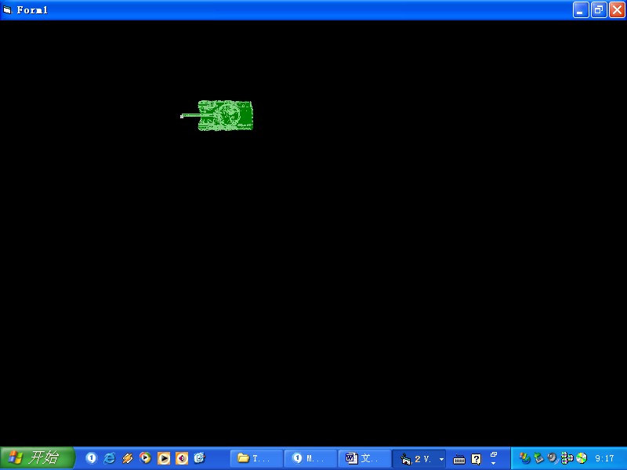
When the tank fires we will need to position the bullet in a position relevant to the tank.
The trajectory i.e. the direction that the shell will move must be set to the direction that the tank is facing – i.e. the trajectory of the shell must be set to the direction of the tank.
However, once fired the shell should move independently. If the tank moves in another direction we would want the bullet to carry on in the path set (i.e. the shell’s trajectory) irrespective of the tanks changed position. Setting an independent trajectory for the shell allows for this.
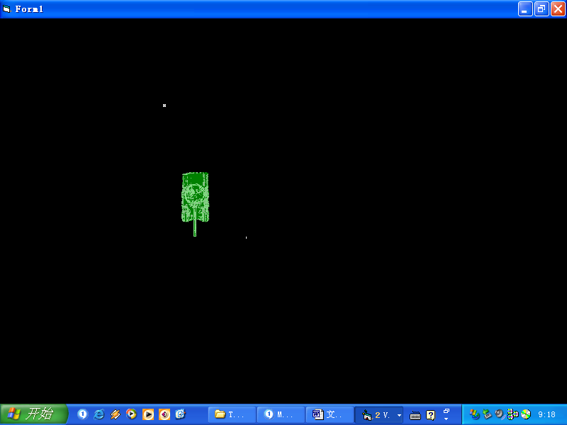
In this case the tank has moved in a new direction downwards but the bullet should still head towards the left.

In order to do this we must set the bullets trajectory path.

Setting the trajectory
The following is in pseudocode – you will need to translate into C#:

You will need to keep values for:

Tank trajectory
The trajectory of the shell

Set the direction of movement

Example: these will need to be declared Class-wide
int P2Tank_traj, p2Shelltraj;

On KeyDown…
……

Case move left:
Set image to left
Set trajectory to left

Case move right:
Set image to right
Set trajectory to right

Case move up:
Set image to up
Set trajectory to up

Case move down:
Set image to down
Set trajectory to down

The code within each case stays the same as in previous labs - apart from 1 line added for each tank direction in order to mark the direction i.e. the trajectory.

Example:
if (e.KeyCode.ToString() == '4')
{
pictureBox2.Image(Image.FromFile(path + "tank1.bmp"));
pictureBox2.Left(pictureBox2.Left - 5);
P2Tank_traj = 1;
}

At the start of the program run we will need to set an initial trajectory for the tank i.e. whatever way facing when the form is loaded. We will also need to initialize values for the shell e.g. so that it does not appear on the screen until the player fires

When the form Loads
….
Set initial tank trajectory

Call initialize

End Sub
Code as for previous labs
Set the initial trajectory to the initial direction of tank on load.
Call a function to initialise the values for the player.

Example initialize function:

private void initialisep2firing()
{

pictureBox3.Left = -100;
pictureBox3.Top = -100;

p2Shelltraj=0;
p2shelllive = false;
}

The image is set of screen so that it is not seen.
trajectory is set to 0.
The bullet is not firing.

We are also keeping a value for whether the bullet is live i.e. firing. This must be devlared.
boolean p2shelllive;

This should be declared class wide.

Modify the case used for player firing within the keypress event
Call the function
The shell is now firing we use a Boolean value to signify this and use it to prevent re-firing i.e. the image being reset to a new position before going offscreen or hitting the target.
We know the trajectory of the tank and so we now call a subrouting to set the trajectory of the shell.
if (e.KeyCode.ToString() == '5')
p2firing();

private void p2firing ()
{
p2shelllive = True;
SET_TRAJECTORY();
}

Setting the Trajectory of the Shell

private void SET_TRAJECTORY()
{
if (P2Tank_traj == 1)
{

pictureBox3.Left = pictureBox2. Left;
pictureBox3.Top = pictureBox2.Top + (pictureBox2.Height / 2));
p2Shelltraj = 1;

}
Tank trajectory

Set the position of the shell image to the midpoint of the tank i.e. where the gun turret is.

The shell trajectory is set to the same trajectory as the tank. The tank trajectory may subsequently change but the shell trajectory will remain

We do this for each possible direction:

if (P2Tank_traj == 2)
{
pictureBox3.Left = pictureBox2.Left + pictureBox2.Width;
pictureBox3.Top = pictureBox2.Top + (pictureBox2.Height / 2);
p2Shelltraj = 2;
}

if (P2Tank_traj == 3)
{
pictureBox3. Left = pictureBox2. Left + (pictureBox2. Width/2);
pictureBox3.Top = pictureBox2.Top + pictureBox2.Height;
p2Shelltraj = 3;
}

if (P2Tank_traj == 4)
{

pictureBox3.Left = pictureBox2.Left + (pictureBox2.Width / 2);
pictureBox3.Top = pictureBox2.Top;
p2Shelltraj = 4;

}

At the end you should see that each time you fire the shell is set to a position at which the tank fires and remains there and so in the next lab we will build in movement for the shell.

